Instruction Microsoft Forms

To use the formats with evaluation questions, the following steps are necessary.

Copy template
Click on the link of the format you want to use.
Click ‘dupliceren’ at the top of the form.
After this you will be redirected to your own Microsoft account (UMC-utrecht) and the document will be automatically opened and saved on your own account.

Customize template

the form and consider whether all the questions apply to your education. If not, you can make adjustments.

2a. Add description
Click on: “write an explanation to the students”:
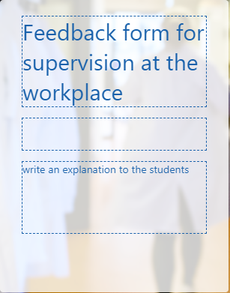
Adjust the text.

2b. Add questions and items
Click on the question under which you want to add a new question.
Click on “add”:
You have the following choices:
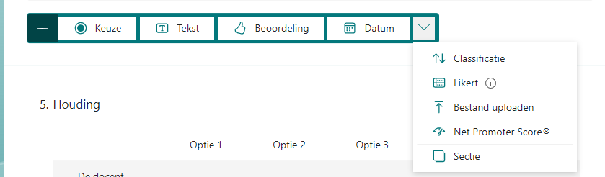
- Keuze: multiple choise question
- Tekst: open question
- Beoordeling: scale question
- Classificatie: arrange the questions
- Likert: rating questions
- Sectie: New section, you can make a new page in the questionaire

Add Item:
Click on the question where you want to add a new item and click on add instruction:

2c. Copy questions
Click on the following button:
The question will be placed under the current question. By means of the arrows at the right side you can move the question up or down.

2d. Delete questions or items
Click on the question or item you want to delete
Click on the bin next to the question or item
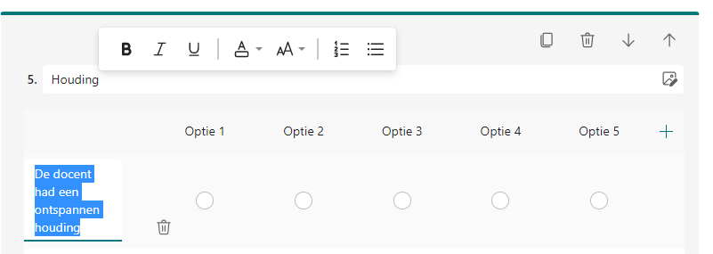

The form will be saved automatically.

Share or use the form.

At the top right are a number of headings: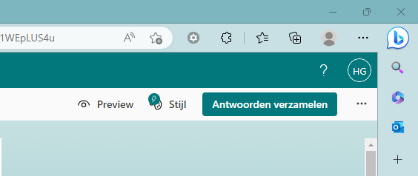
Preview: this lets you see what the document will look like when shared with others
Stijl: In this section you can change the lay-out
Antwoorden verzamelen: In this section you can share a hyperlink to the participants to collect answers
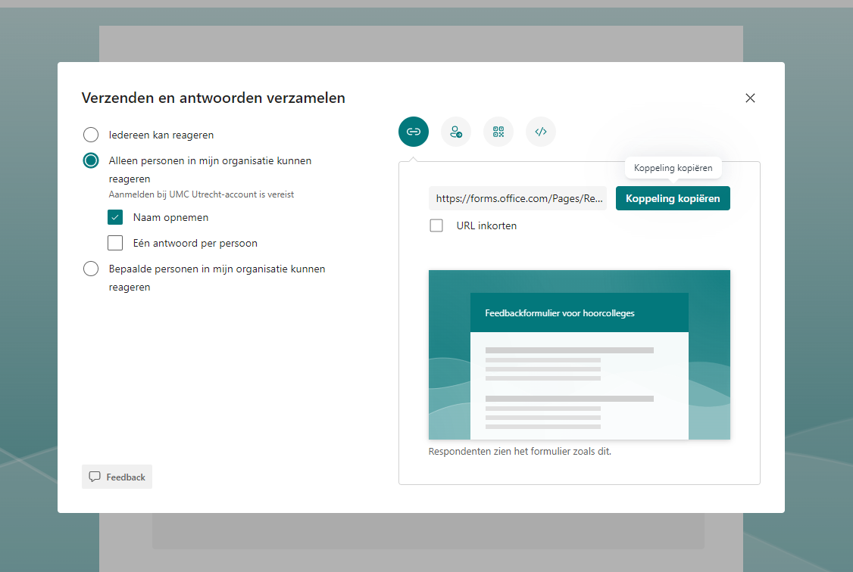
Choose the options which are relevant for you.
Choose right how you want to share the form. This can be done by hyperlink, QR-code or inbedded for an lms system.
If you want to print the form, this can be done in the following way:
Click on the three dots next to ‘antwoorden verzamelen’.
Click on ‘formulier afdrukken’ and select to correct printer
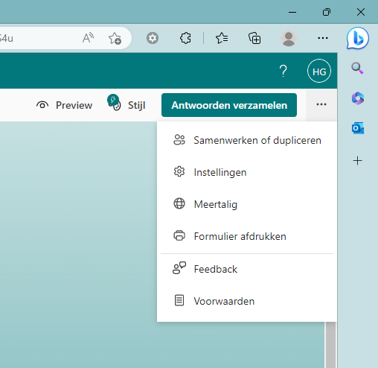

Find your form
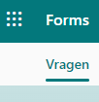
Go to forms.office.com of click on:
Here you find an overview of your forms.
Click on the form you want to analyse or adjust.
Also in this place you can make a new form.

Collect answers and analyse answers
When the questionnaire has been completed digitally, you can find the answers digitally. Click on answers at the top left of the screen
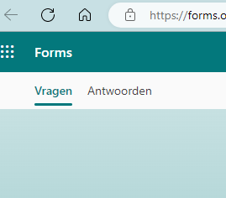
You can find some data:
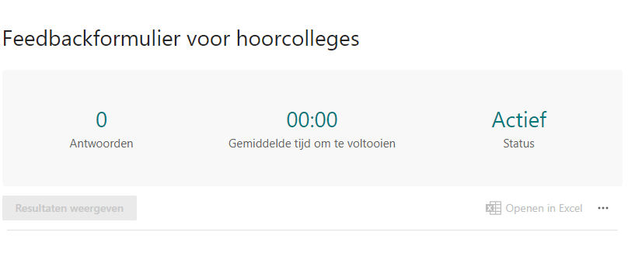
With ‘antwoorden’, you can see how many respondents there have been and how much time was spent on average filling in the form.
‘actief’ means that the questionnaire is still available to answer. You can set it to inactive in settings.
Below this screen you see the results per question, per individual respondent (by clicking on show results)
You can download the answers by opening them in Excel.

